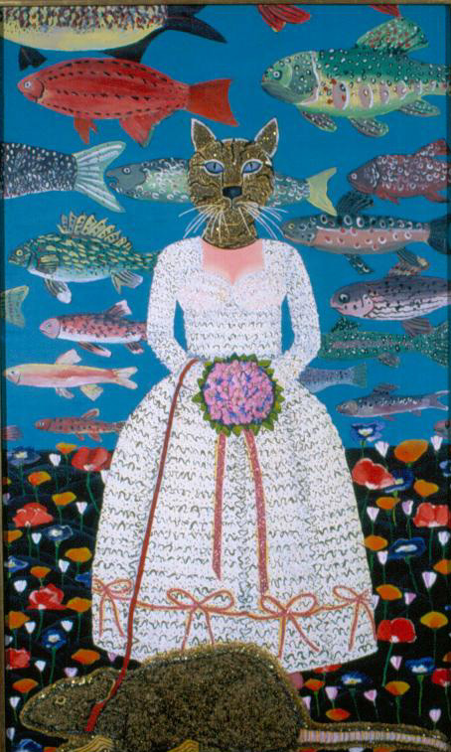
Topics in Modern & Contemporary Art 116
Circa 1970: Art in Greater Sacramento
Joan Brown, The Bride, 1970. Brown taught at Sacramento State 1970-71
,
Bro
Tuesday 1:30-4:20 pm
Brighton Hall 208
Professor Elaine O’Brien
Office Hours: Tuesday and Thursday 4:30-6:00 pm
Office: Kadema 190
eobrien@csus.edu
http://www.csus.edu/indiv/o/obriene/
For me, being picked up by the University of California at Davis was, in a way, like the Medicis deciding that they were going to sponsor me as an artist . . . it was just a great experience, being able to be somewhere.
Robert Arneson, 1981

Course Description:
This seminar focuses on the art produced by faculty and student artists associated with UC Davis and Sacramento State loosely between 1965 and 1975: a transformative decade in this region, as it was everywhere. The historically significant art of this time responds to and is part of the paradigm shift that occurred after the Age of Europe (c. 1492-1945) when world culture turned from the modern toward the postmodern, from the hegemony of exclusive Euro-American modernism to the inclusive, global postmodernism of contemporary art. Readings focus on artists in the Sacramento-Davis-Folsom area whose work was at the forefront of world art in the sixties and seventies. We consider the radically changed social, political, and economic situations of the artists: the impact of the Civil Rights, Anti-War, and Free Speech movements and the new art departments at Sac State and UC Davis who were the great patrons of the art we study. The seminar hosts artists and art professionals and takes field trips to the Crocker Museum of Art in Sacramento and the Di Rosa Collection in Napa to see the art in person. The seminar research paper is a catalog entry for the Sacramento State Art Collection website http://csus.edu/art/artcollection/ and the collection catalog, Selected Works from the Sacramento State University Art Collection, which is available for purchase on BLURB.com.
*NOTE: On Friday, November 10, the class will visit and take a docent-led tour of the Di Rosa Collection in Napa. This is a required all-day class trip that makes up for two seminar sessions. Please talk to me right away if you cannot go on November 10.
Course Prerequisites: Upper-division status; completion of the University’s Graduation Writing Assessment Requirement; completion of Art 1B, Art 1C or equivalent; and an upper-division course in a related subject area or instructor’s permission.
Required Readings:
There is no textbook. All required readings (listed on the syllabus schedule) are available on the course website for you to download. Please print each one out, mark and annotate it for discussion, and bring all assigned readings to class with your reading response paper, described below.
Note on course costs: We are taking two class trips to museums: The Crocker and the Di Rosa Collection. That will cost gas money as well as parking and admission fees.
Grading:
15% // Participation: The success of the seminar depends on preparation and team work. Each person must come to seminar having completed the readings and response papers. In discussion, practice engaged listening and responding, respect the opinions of others, make eye contact with everyone when you speak, and ask questions of speakers that might help clarify our thinking. Do not monopolize class discussions, but don’t hold back either. Good participation can raise your course grade by as much as a whole letter; poor participation can lower it proportionately.
- Attendance policy:
  - Illness (including mental illness), yours or someone you are responsible for, and family emergencies are excused. To be excused, bring me a medical excuse. For emergencies, tell me in person (privately, in my office) what happened as soon as possible.
  - Each unexcused absence reduces your grade by half a letter. Three unexcused absences result in failure.
  - Work, transportation problems, and any scheduled (non-emergency) appointment are not excused.
  - Repeated lateness and/or leaving early can reduce your grade by as much as a whole letter.
  - No matter how valid your reasons for missing class, however, after four absences, excused or unexcused, you will be asked to withdraw from the course.
If you have a disability and require accommodations, you need to provide disability documentation to SSWD, Lassen Hall 1008 (916) 278-6955. Please discuss your accommodation needs with me after class or during my office hours early in the semester.
45% // 200-word RResponse (reading response) papers: double space, 12 font. For each
of the readings indicated “RR” on the syllabus:
- On top of the page write your name, date, the full title of the reading, the author’s name and expertise (you might need to search online for the expertise).
- Find and quote the author’s thesis statement (put the page number in parentheses after the quotation)
- Paraphrase the author’s thesis statement.
- Find two statements that support the thesis and quote them. Put the page number for each. Select statements from the first and second half of the reading.
- After each quotation, restate the author’s statement in your own words. Your paraphrase should be about the length of the quotation and include all the points made in the quotation. Try to select statements that make one point only.
- Conclude with what you learned about the seminar topic overall from the reading.
Each Reading Response (RR) is graded on a 1-10 scale based on 1) thoughtfulness and 2) evidence of time spent to understand and correctly paraphrase the author, 3) how well the assigned format is followed, 4) completeness, 5) grammar and spelling.
NOTE: RResponse papers are accepted late only with an excused absence. Attach the medical excuse or attach a note reminding me that you talked with me about your absence and I excused you.
40% / Catalog entry (with a 10-minute PowerPoint presentation) for the Art Department art collection website and the Selected Works from the Sacramento State Art Collection catalog.
Write a catalog entry on an artwork in the Sacramento State Art Department Art Collection for the collection website and the Selected Works catalog (1000 words). This is a professional-level catalog entry for one artwork from the 1960s or ‘70s in the Sacramento State art collection, including public art on campus. You will be given instruction and access to previous student catalog entries to use as models.
- Catalog entry format and content:
  - Begin your essay with a 200-word description and analysis of the artwork from direct examination of it. Make an appointment with Nancy Wylie to see the artwork. She will tell you how to handle the art and supervise you. Take careful descriptive notes and as many photographs of the object as you think you will need. Include closeups of details. For three-dimensional objects, take pictures from all sides.
  - Note any damage on a conditions report.
  - Research the historical contexts of the artwork and artist’s relevant experience, the artist’s intentions and related works.
  - Include footnotes and a select bibliography in correct Chicago style.
  - Your research will be both primary (interviews and original documents) and secondary (interpretive essays and reviews). There may be little written about your specific piece, in which case you will need to extrapolate from the information you find about related works by that artist that were created around the same time.
- Due dates for catalog entry:
  - September 19: Proposal due. Submit subject selection with a bibliography of three strong sources in correct Chicago style. List artist’s name, title, date, medium and where it is located now. Put your three sources below in correct Chicago 16th edition bibliographic style. Use Endnote.
  - October 31: First draft of catalog entry due
  - December 5: Final draft of catalog entry due
  - December 5: Present a 10-minute illustrated PowerPoint about your artwork
___________________________________________________________
Schedule (subject to changes announced in class)
NOTE: All readings below are available on the Art 116 “Readings” webpage. Follow the directions for *RResponse papers on p. 2 of the syllabus.
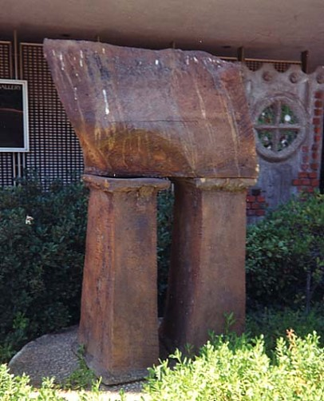
August 29: Introduction / Review of the Sac State Art Collection Catalog / Instruction in Endnote/
View 1990 award-winning film by Mark Kitchell, Berkeley in the Sixties, for historical context of the art we are studying this semester.
*RR:
Steve Kaltenbach, Untitled, 1965, ceramic sculpture, Kadema Hall, Sac State
- Susan Landauer, “Countering Cultures: The California Context (An Overview),” from Peter Selz, Art of Engagement: Visual Politics in California and Beyond, 2006 (this and all readings are available on the Art 116 “Readings” webpage)
- Jonathan Fineberg, “Identity and Embodiment, 1961-69,” from Fineberg, A Troublesome Subject: The Art of Robert Arneson, 2013
September 5: Overview lecture
*Deborah Metzger, CSUS Science and Technology Librarian, will give us a demonstration of how to use Endnote.
NOTE: You can download the app (free from the University) on your laptop before class if you want to follow along.
View: “Revolutions of the Wheel, part 5: Robert Arneson and the Davis Group”
*RR:
- Robert Hughes, “The Poet of Pastry: Wayne Thiebaud” 2001
- Joann Moser, “What’s It All Mean?” from What’s It All Mean: William T. Wiley in Retrospect, 2010
September 12:
Due: Three catalog essay subject choices
*RR:
- Elaine O’Brien, “Bad Ideas: The Enigma of Stephen Kaltenbach,” Midtown Magazine, 2009
- Constance Lewallen, “A Rose Has No Teeth,” from Lewallen et al., A Rose Has No Teeth: Bruce Nauman in the 1960s, 2007
September 19: Steve Kaltenbach
Due: Proposal for catalog entry due
*RR:
- Robert Morris, “Anti Form” (1968)
- Marcia Tucker and James Monte, Anti-Illusion: Procedures/Materials (Whitney MA catalog, 1969), available at this website: https://archive.org/stream/antiillusionproc61whit#page/n3/mode/2up (NOTE: if the syllabus link fails, search online using the authors’ names and exhibition title to get the document on your own from The Internet Archive.)
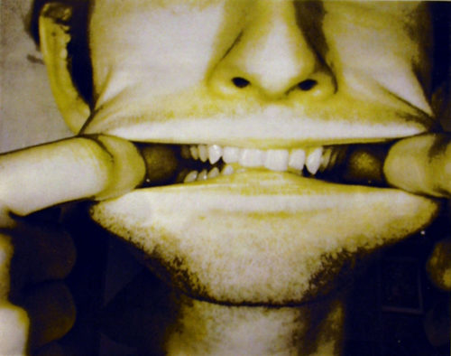
September 26: Ellen Van Fleet
Watch “Judy Chicago & the California Girls” DVD 000764
*RR: Gail Levin, “Becoming Judy Chicago,” abridged essay from Jill Fields, Entering the Picture Judy Chicago, the Fresno Feminist Art Program, and the Collective Visions of Women Artists, 2012
Bruce Nauman, Studies for Holograms (detail), 1970. Five photo silkscreens, di Rosa Collection, Napa. Nauman got his MFA from UC Davis in 1966.
October 3: Vicki Hall
*No RResponse assignment
October 10: Class meets at the Crocker Art Museum 3:30-5:30 pm for a focused tour. Bring your Sac State OneCard for ID and $8 student admission
*RR:
- George Lipsitz, “Not Just another Social Movement: Poster Art and the Movimiento Chicano,” from Just Another Poster? 2001
- Ella Diaz, “Introduction: Mapping the Chicano/a Art History of the Royal Chicano Air Force,” from Flying Under the Radar with the Royal Chicano Air Force, 2017

October 12: Julia Couzens lecture: University Library Gallery, 3-5 pm. Extra credit for attendance.
October 17: Xico Gonzalez on the Chicano/a art movement, Sacramento State and UC Davis
View: “Pilots of Aztlan flights of the Royal Chicano Air Force,” Steve LaRosa
*RR:
- “DQU: Their Own Place in the Sun,” Peter Janssen, 1973 (4 pages)
- Peter Selz, “The Native American Experience,” from chapter “Racism, Discrimination and Politics of Identity” in Art of Engagement 2006
- “Pacific Western Traders,” by Peter Nabokov (6 pages)
- Lowery Stokes Sims, “Scholder’s Figuration: Art and Culture in American Art”(2008)
- Watch (no RR) Interview of Frank LaPena by Carlos Villa: http://rehistoricizing.org/frank-la-pena/.
Use the interview and the RR readings above to prepare two substantive questions for Frank La Pena on October 24. Write the questions down and attach them to your response paper.
Note: Carlos Villa was an Associate Professor in the Sac State Art department from 1969-79.
October 24: Frank La Pena
*RR:
- Holland Cotter, “Provocateur: The Peter Saul Manifesto” http://www.nytimes.com/2008/08/16/arts/design/16saul.html
- James Yood, “Gladys Nilsson,” from Gladys Nilsson, 1993
- Jonathan Fineberg, “Chicago and Points West,” “West Coast Pop,” and “Robert Arneson”: selections from Art Since 1940: Strategies of Being
October 29: Opening of the exhibition, Exuberant Earth: Ceramics by Ruth Rippon, Crocker Art Museum. Extra credit for attendance.
October 31: First draft of catalog entry due / Peter Saul and The Hairy Who in Sacramento: Jim Nutt, Gladys Nilsson, Karl Wirsum / View film: The Hairy Who and Chicago Imagists, 2016
*RR:
- Amy Owen,“Based on a True Story: Highlights from the Di Rosa Collection”
- Christine Giles and Katherine Plake Hough, “Bill, Bob, and Bill,” from Collaborations: William Allan, Robert Hudson, and William Wiley, exhibition catalog, 1998
- Jacquelynn Bass, “To Know the Place for the First Time: Interpreting Joan Brown,” in Karen Tsujimoto and Jacquelynn Bass, The Art of Joan Brown (1998)
November 7:
*RR:
- Peter Selz, “Funk” catalog essay, 1968
- Susan Landauer, “Valley of the Dots: The Early Years at UC Davis,” from Of Dogs and Other People: The Art of Roy De Forest, 2017
- Susan Landauer, “Having Your Cake and Painting It Too,” from The Lighter Side of Bay Area Figuration, 2000
Friday, November 10: Class visit to the Di Rosa Collection, Napa.
NOTE: This is a required, all-day class trip that makes up for two seminar sessions, November 14 and 21
*Di Rosa Assignment: Take two photographs of you with art works by regional artists from the 1960s and 70s (if permitted). Ask another student to photograph you, so you get the whole artwork into the pictures. You don’t need to look at the camera and smile if you don’t want to. Take descriptive notes about the art you photographed; copy the information from the wall texts, and do some online research about the artist and artwork. Write 200-300 words about the one work of art that interests you the most. Fully identify the artwork (artist’s full name, birth and death dates, title, date, medium, movement if relevant, and donor). Describe it and write a report from the information you gathered. Cite your sources correctly using Chicago 16th style.
November 14 & 21: No Class
Makeup assignment: Class Di Rosa Collection visit, Friday, November 10, and Di Rosa assignment described above.
November 28: Di Rosa assignment due
Guest speakers on regional art galleries in the 1960s and 70s
December 5: Catalog entry due / Power-Point Presentations

